

**Green University of Bangladesh**

**Department of Computer Science and Engineering (CSE)**

**Faculty of Sciences and Engineering**

**Semester: (Spring, Year:2021), B.Sc. in CSE (Day)**

**Course Title:** Data Communication Laboratory

**Course Code:** CSE 308 **Section:** DA

**Lab Project Name:** Checking whether the data is secure or not by checking error detection. **_ _ _ _ _ _ _**

**Student Details**

|  |  |  |
| --- | --- | --- |
| **Name** | | **ID** |
| **1.** | Shakib Imtiaz | 202902008 |
| **2.** | Jannatul Mayeda | 202902030 |
| **3.** |  |  |

**Submission Date: _ _ _** 09/09/2022**_ _ _ _ _ _ _ _ _ _ _ _ _ _ _ _ _ _ _ _ _**

**Course Teacher’s Name: _ _ _ _**Rushmita Halim Chayti **_ _ _ _ _ _ _ _ _ _ _**

**[For Teachers use only: Don’t Write Anything inside this box]**

|  |
| --- |
| **Lab Project Status**  **Marks: ………………………………… Signature: .....................**  **Comments: .............................................. Date: ..............................** |

Contents

**Chapter 1 Introduction 3**

1.1 Introduction 3

1.2 Design Goals/Objective 3

**Chapter 2 Design/Development/Implementation of the Project 4**

2.1 Section (Choose the name of this section as appropriate with your project) 4

2.2 Section (Choose the name of this section as appropriate with your project) 4

2.2.1 Subsection 4

**Chapter 3 Performance Evaluation 5**

3.1 Simulation Environment/ Simulation Procedure 5

3.2 Results and Discussions 6

**Chapter 4 Conclusion 6**

**References 7**

# Chapter 1 Introduction

## Introduction

The project is for checking whether the data is secure or not. Generally, we can check the data secure or not by implementing Parity checking, Cyclic Redundancy Checking, Humming Code implementing excreta ways. Is this project, we have implemented Parity checking, Cyclic Redundancy Checking, Humming Code for detecting the errors from the data. We have used c++ programming language for giving the compete overview of this project.

## Design Goals/Objective

Generally, whenever we send any data, it can be incurred, or there will be some errors. Therefore, we want to develop a project named “Checking the data is secure or not by checking error detection”. In this project, we will use the concepts of parity check, a cyclic redundancy check and humming code. This project will help us to ensure data security and keep the data more usable.

# Chapter 2

# Design/Development/Implementation of the Project

## Implementation

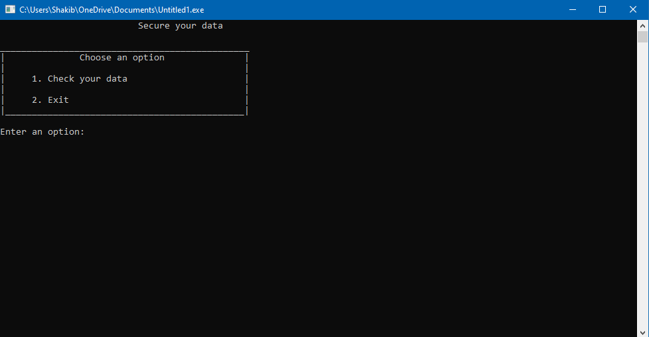 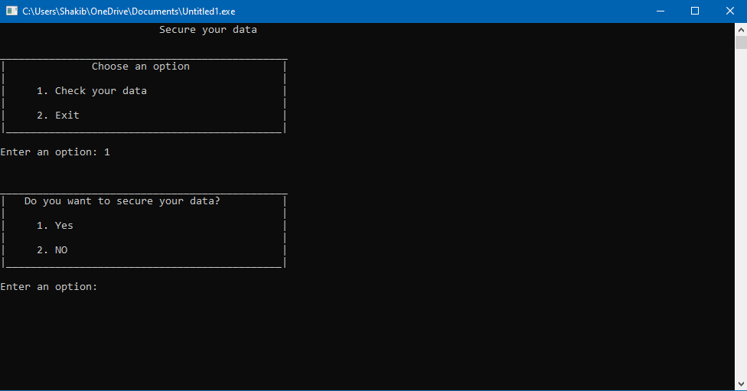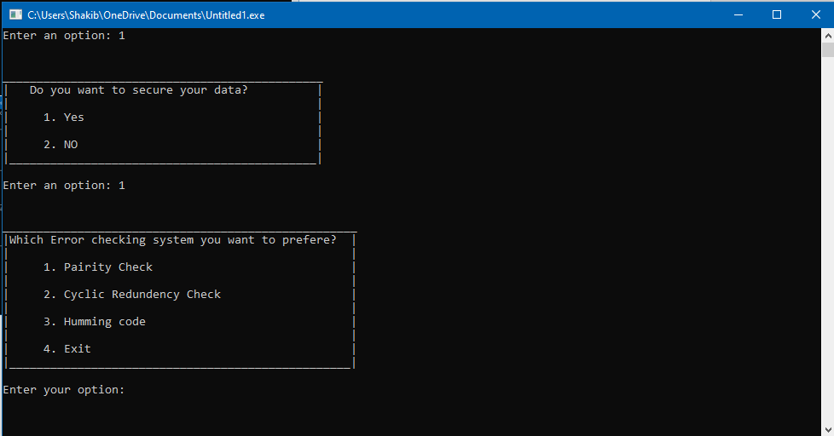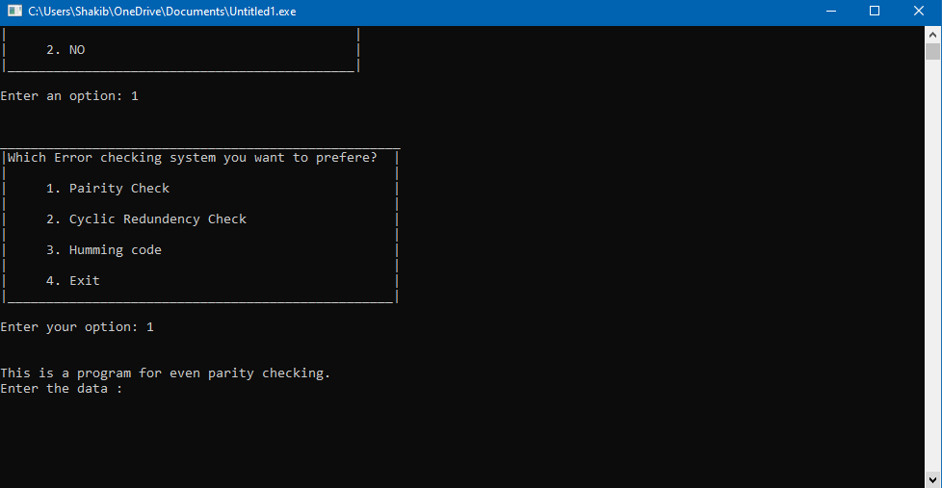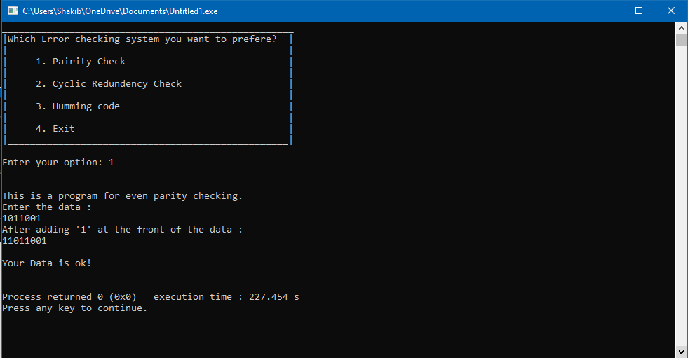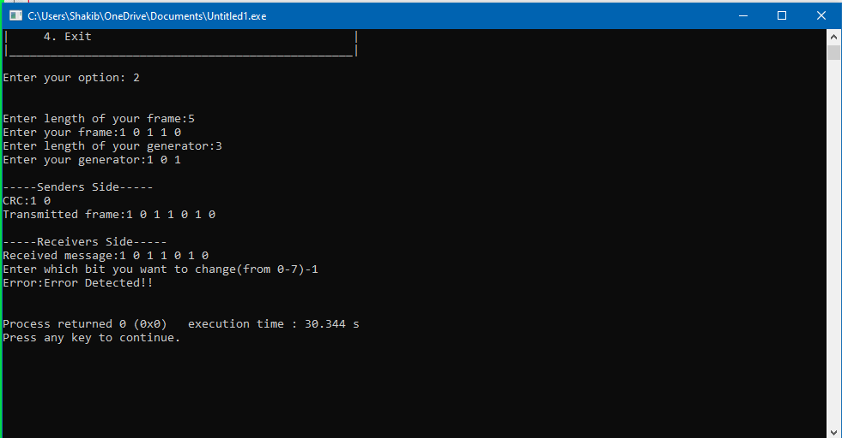

# Chapter 3 Performance Evaluation

## Simulation Environment/ Simulation Procedure

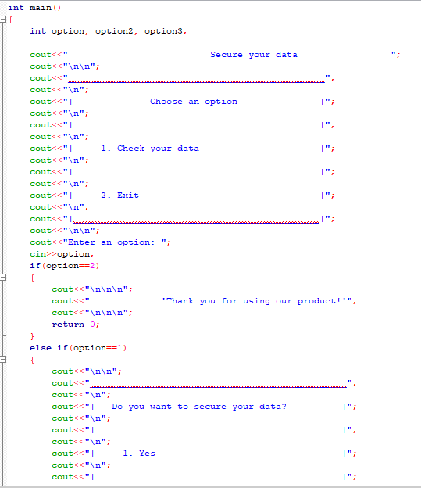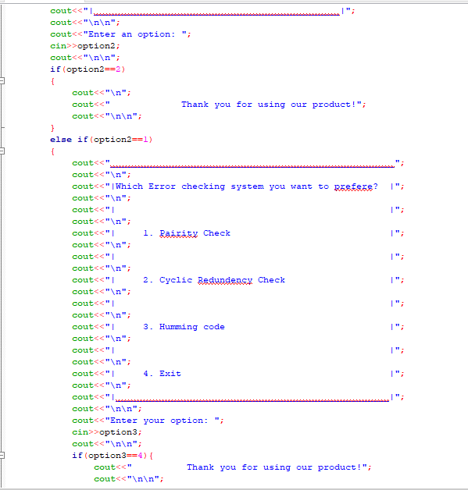

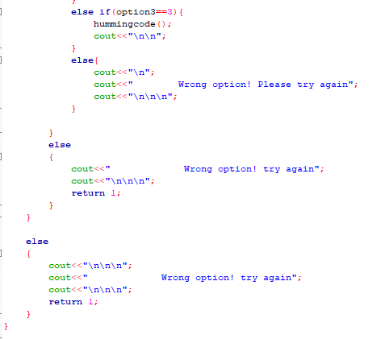

## Results and Discussions

Successfully worked and giving the correct output. All the functions are working perfectly and no error has been occurred on this project. The project is ready for longing.

# Chapter 4 Conclusion

Our ultimate goal is to secure users’ data. No noise should be created. Both the sender and the receiver will get perfect communication between them. That’s why we have made this project and implemented.

# References

1. https://www.geeksforgeeks.org/program-to-find-parity/
2. https://en.wikipedia.org/wiki/Cyclic_redundancy_check
3. https://en.wikipedia.org/wiki/Hamming_code#:~:text=In%20computer%20science%20and%20telecommunication,without%20detection%20of%20uncorrected%20errors.